NAME :JAYAHARINI.J

REG NO:192371034

Unit 2

Class Exercise

CLASS WORK

1.HTML CODE

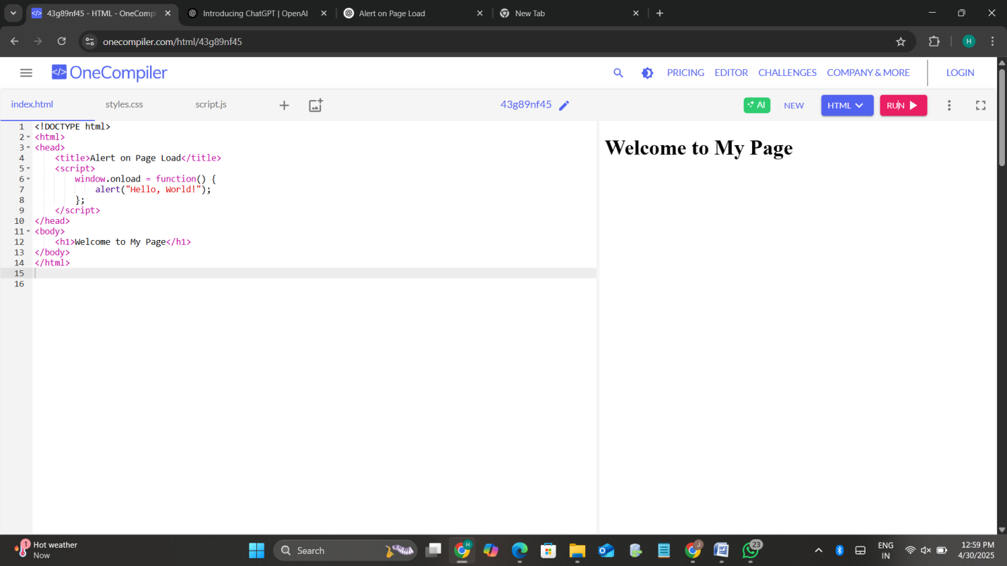

2a) HTML PAGE without paragraph and button

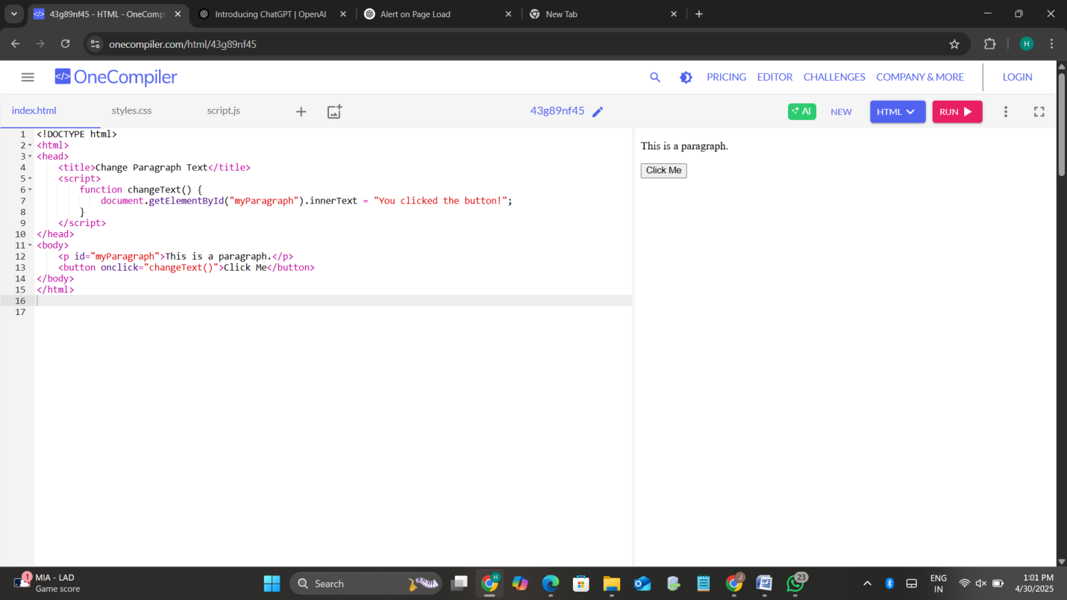

b) Form with username validation on submit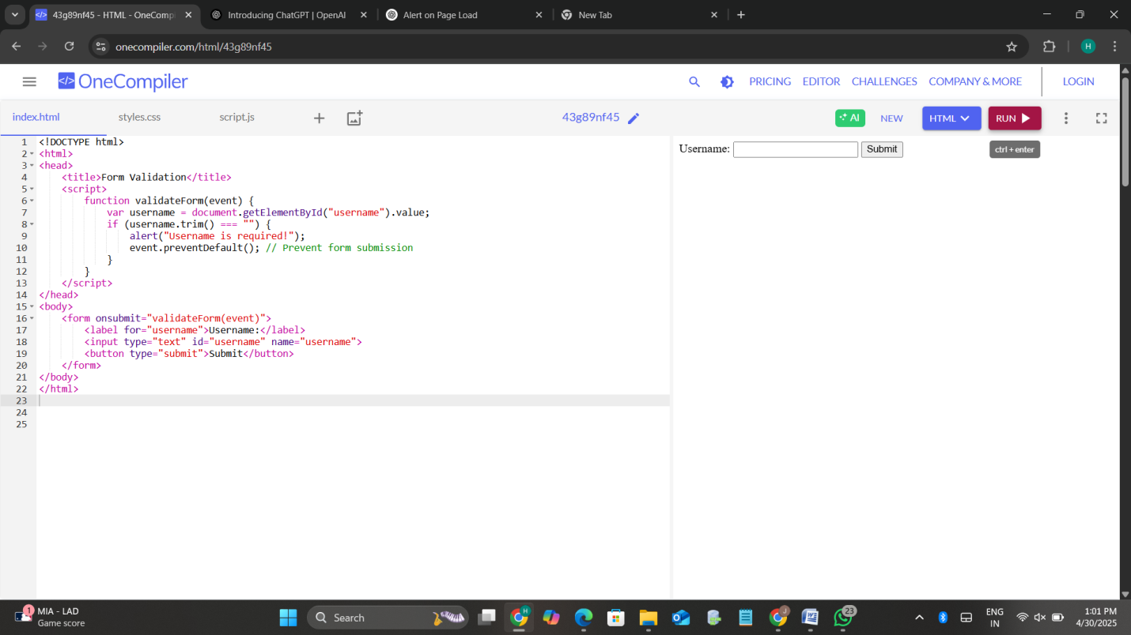

3a) Display current date and time in a <div> when the page loads

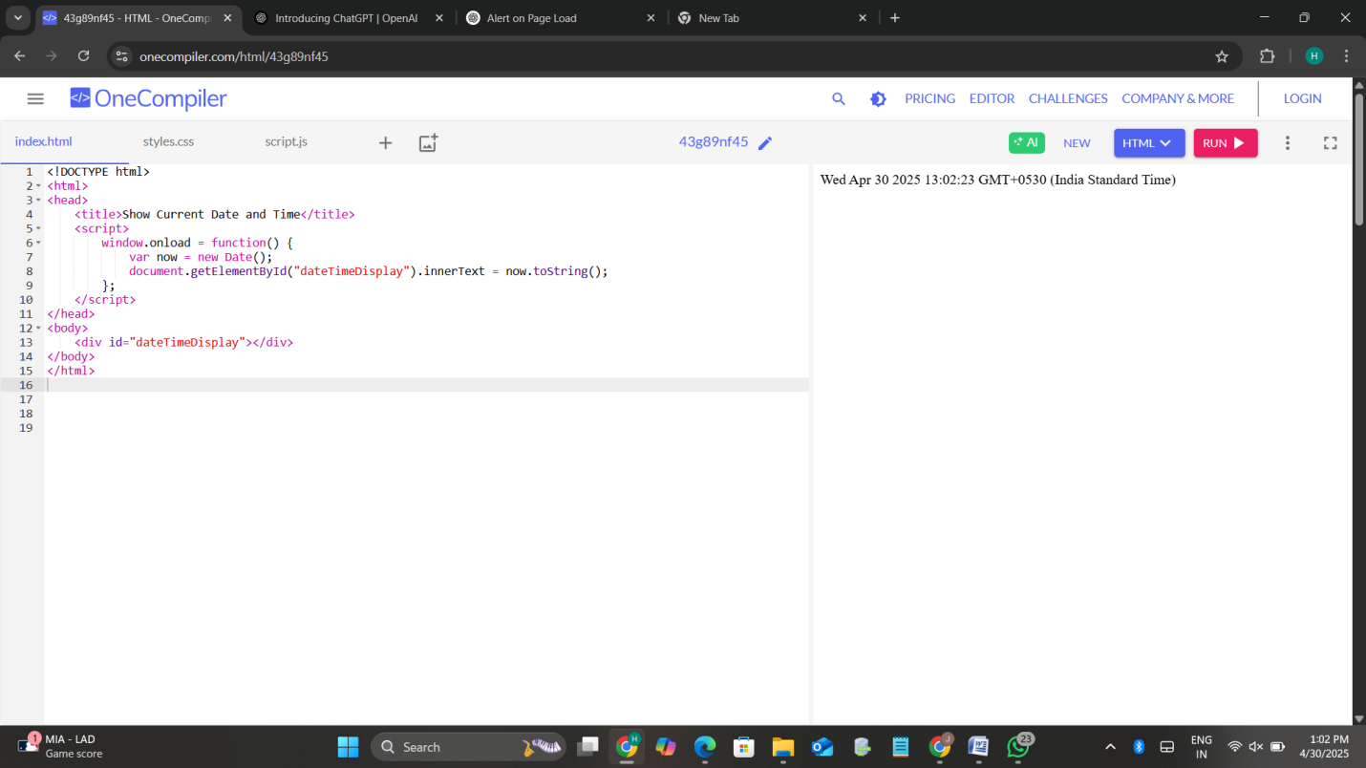

b) Create a simple digital clock using JavaScript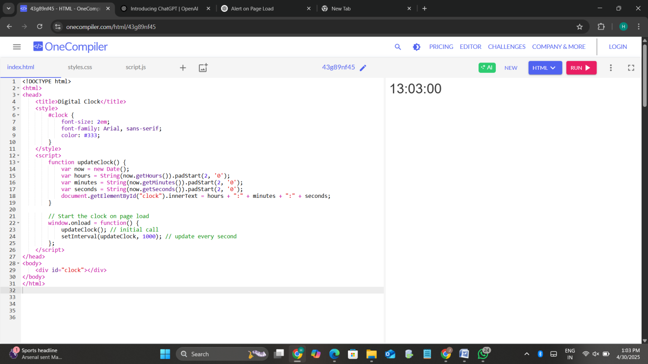

4) Email Validation Form with Regular Expression

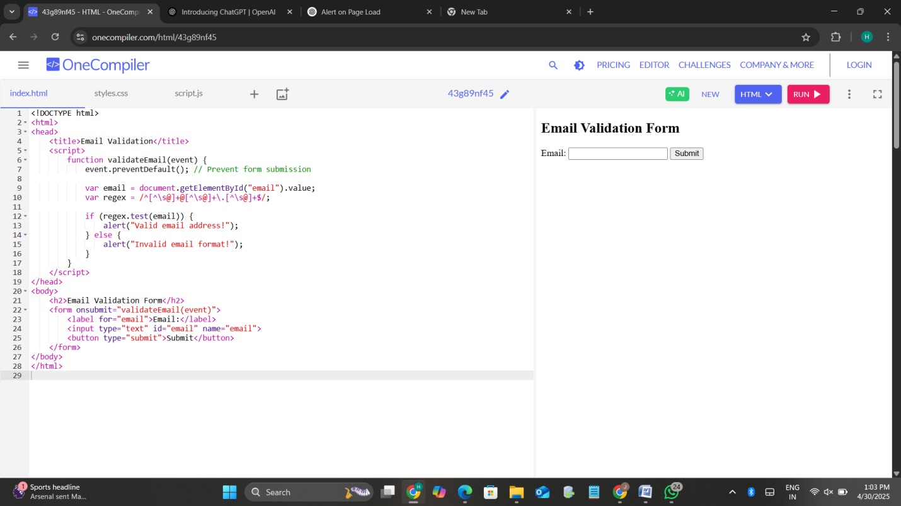

5a) Box that changes color on mouseover and reverts on mouseout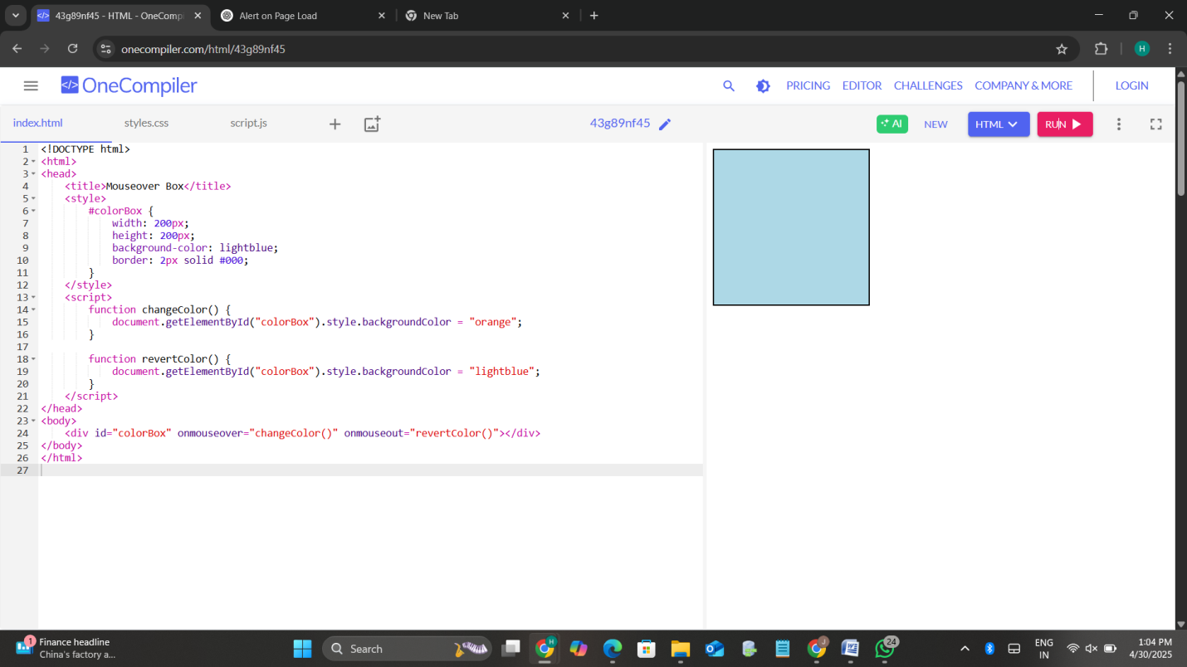

b) Image that smoothly increases in size when clicked (DHTML)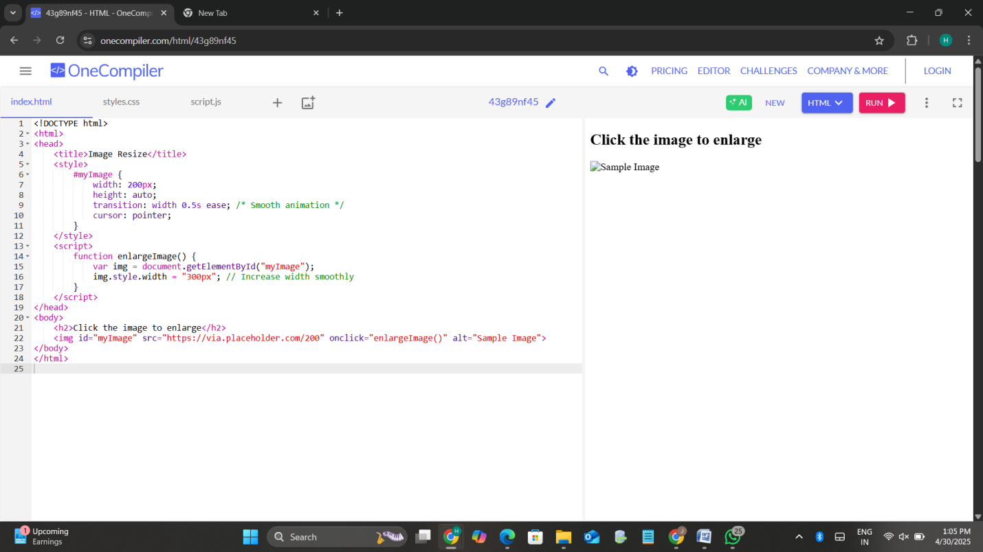

6. Exception Handling

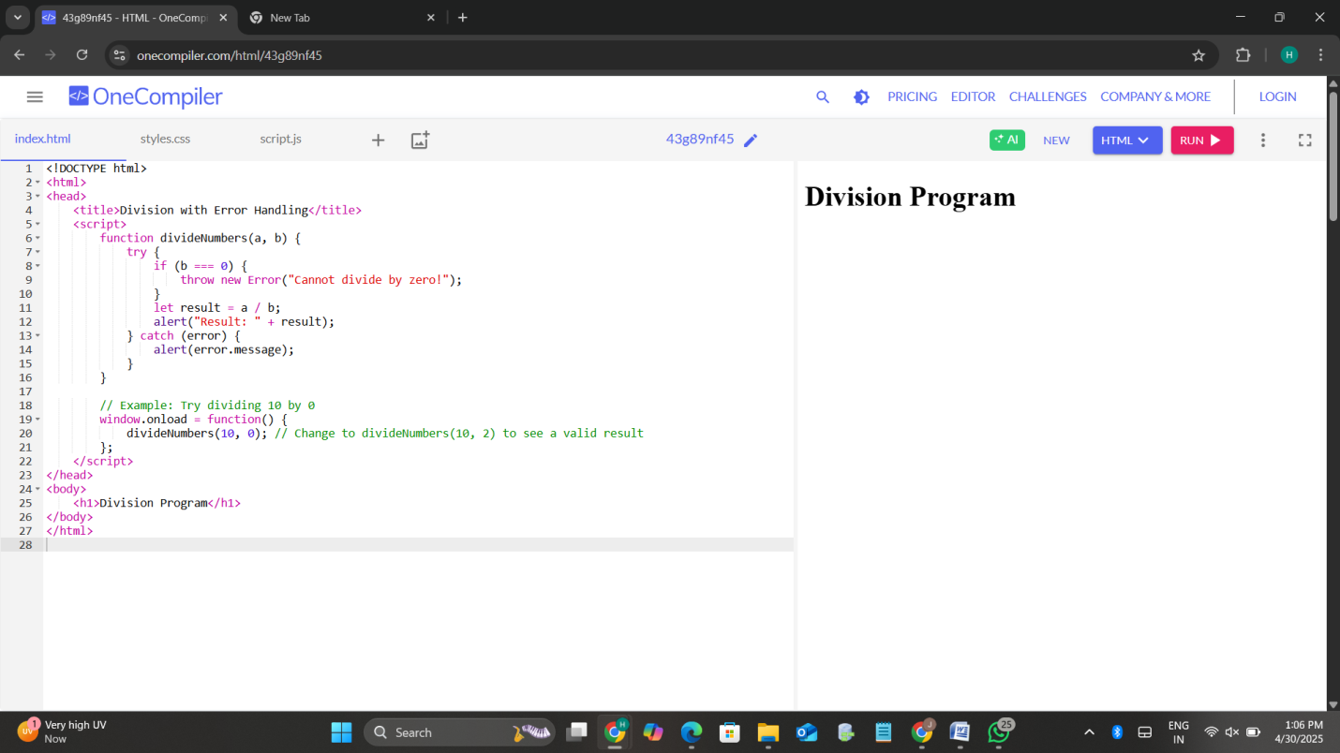

7. Square Root Calculator using JavaScript's Math Object

